Purpose:

This is a set of instructions on how to use the “Disturbance of areas within regions within range” tool to calculate regional disturbance.

The tool was originally designed to determine the amount of undisturbed habitat within protected areas, by region. The tool uses the *range* as a processing mask. It splits up results by *regions*. The key results reported are total area and area of *undisturbed habitat* within *areas of interest*.

To calculate regional disturbance (instead of disturbance within *areas of interest*) we simply use the *regions* file as both the *regions* file and as the *areas of interest* file.

1. GATHER LAYERS

These are the files that are required to perform this analysis:

* Fire data
* Anthropogenic disturbance data
* NT1 range file
* Regions file
* {optional} undisturbed habitat file – if you have this, skip to step 3).

1. CREATE UNDISTURBED HABITAT FILE

Prior to using the tool, we need to create our *undisturbed habitat* file. This is done by **selecting** the appropriate 40 year window from the fire data and **exporting** it. **Merge** the result with your anthropogenic disturbance data. Use the merged file to **erase** the NT1 range file. The result of this erase is your *undisturbed habitat* file.

1. USE THE TOOL

Below are the field descriptions.

Range file: The mask for the entire operation. Nothing outside this will be included in the outputs.  
Regions file: The output will be divided by the features in the regions file.  
Regions file ID field: This field must contain unique identifiers for the regions.  
Areas of interest file: The regions will be subdivided up by the areas of interest. Results are reported for each area of interest for each region.. Areas of interest can cross regional boundaries. They can also overlap, but the output does not provide a non-overlapping total of values.  
Areas of interest ID field: This field must contain unique identifiers for the areas of interest.  
Additional fields to carry over (optional): Any additional information that the areas of interest attribute tables hold can be carried over to the output. This allows post-tool sorting of outputs by pre-set categories. Input the additional fields separated by commas ("," without quotes).  
Undisturbed habitat file: This file outlines the areas that will be used to define the areas in the "undist" section of the outputs.  
Output location: The folder where the output file geodatabase and csv summary will be created.

Run output name: The name that will be assigned to the outputs.  
Area factor: This is the factor by which the base map unit values (from the automatic file geodatabase field "Shape_Area") will be multiplied to obtain the output units. 0.0001*(any values in metres squared) gives a result in hectares.

Inputs should be as follows:

Range file: select the range file.  
Regions file: select the regions file.  
Regions file ID field: enter the name of the field in the regions file that identifies the regions. No special characters or spaces should be in the region names.  
Areas of interest file: select the regions file.  
Areas of interest ID field: enter the same as for the “Regions file ID field”.  
Additional fields to carry over: Ignore this field. Do not enter anything.  
Undisturbed habitat file: select your undisturbed habitat file  
Output location: select any folder. Outputs will be created there.  
Run output name: create an output name. Do not use spaces or special characters.  
Area factor: leave this as is, or follow the description to obtain results in a different unit.

Fig 1. Shows the tool with a sample set of inputs.

Intro

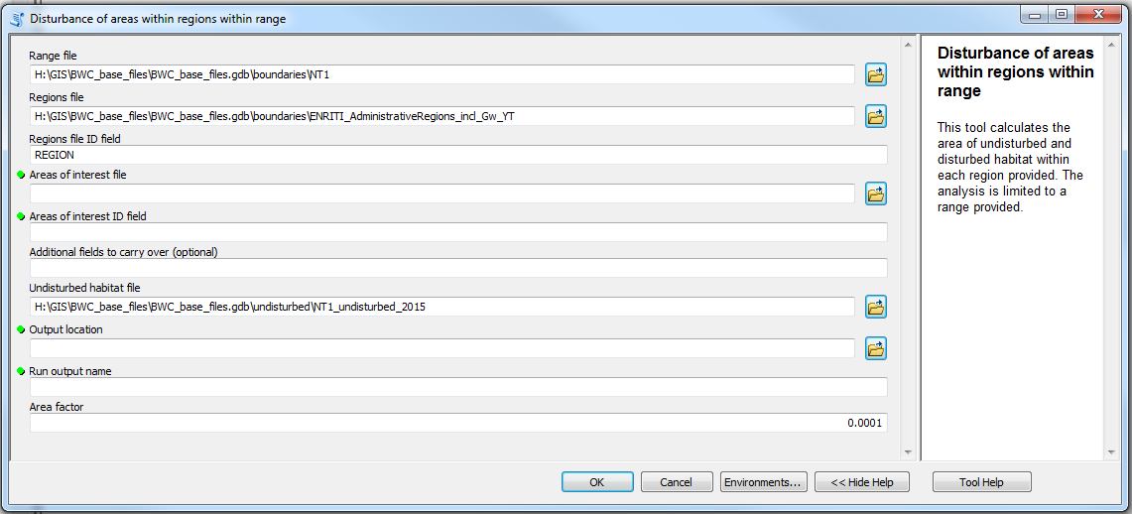

Fig 1. The input dialog for the “Disturbance of areas within regions within range” tool. Very pretty.

This tool was originally designed to **calculate the area of and the areal extent of disturbance** **within** *areas of interest*, by *region*, within an overall *range*. Let’s step back and look at that sentence.

The ‘range’ file is like mask for the whole operation. Anything that falls outside of the range will not be considered in the output. This file should contain the regions, areas of interest, and the undisturbed habitat.

The ‘regions’ files is a subdivision of the range.

The ‘areas of interest’ file is a further subdivision of the regions. Results are calculated for the amount of “undisturbed habitat” within any given area of interest. Overlapping results are not accounted for, and should be accommodated before the analysis begins. If areas of interest cross a regional boundary, only the portion within the region in question will be reported for that region.

The ‘undisturbed habitat’ file should show the areas designated as “undisturbed habitat”. Results will detail (for each area of interest, for each region, within the range) the amount of undisturbed habitat.